
POE PART 2 PROGRAMMING 2B
PROJECT PLAN FOR A POE


Matshidiso Nthebe
ST10449727

Table of Contents
Project Plan: Contract Monthly Claim System (CMCS) 2
1. Project Overview 2
2. Purpose: 2
3. Stakeholders & User Roles 2
4. Objectives 3
5. System Workflow 3
6. Requirements 3
Functional Requirements 3
Non-Functional Requirements 4
7. Project Deliverables 4
Database schema (SQL Server) 4
8. Technology Stack 4
9. Project Timeline (8 Weeks) - UPDATED 5
10. Risk Management 5
Entity diagram 6
11. Success Criteria 7
12. Enhancements & Lecturer Feedback Implementation 7
Instruction 7
Implementation Plan 7
Reference List: 9

Project Plan: Contract Monthly Claim System (CMCS)

1. Project Overview
The Contract Monthly Claim System (CMCS) is a web-based platform developed in ASP.NET (C#). It is designed to allow Independent Contractor (IC) lecturers to submit their monthly claims online. The goal is to replace the current paper-based process with a digital solution that provides efficiency, transparency, and a clear approval workflow involving Programme Coordinators and Programme Managers. This document has been updated for Part 2 to detail the implementation of enhanced GUI functionalities.

2. Purpose:
- Streamline and digitalize the lecturer claim submission process.
- Minimize delays, errors, and inefficiencies associated with manual record keeping.
- Provide transparent approval workflows with timestamps and accountability.
- Allow users to upload supporting documents to strengthen claim validation.
- Part 2 Addition: Provide a fully functional, intuitive, and reliable GUI application that meets all user requirements.

3. Stakeholders & User Roles
Users:
Lecturer:
- Registers, log in, submit claims, and uploads documents.
- Tracks claim status in a transparent view.
Program Coordinator:
- Reviews and validates lecturer claims via a dedicated dashboard.
- Approves or rejects claims with a single click.
Program Manager (PM):
- Conducts final approval/rejection via a dedicated dashboard.
- Provides final claim status (Finalized/Rejected By PM).
Stakeholders:
- Students (Developers)
- Academic staff (End users)
- Module Coordinator (Supervisor)

4. Objectives
- Develop a secure, user-friendly claim management platform.
- Implement structured approval workflows.
- Ensure data integrity with a well-structured database.
- Provide auditability via timestamps and status tracking.
- Part 2 Addition: Successfully implement and unit test all specified GUI functionalities for a robust and reliable application.

5. System Workflow
- Lecturer registers and logs in.
- Lecturer navigates to a dashboard and clicks "Submit New Claim".
- Lecturer fills an intuitive form (hours, rate, notes) and uploads supporting documents.
- Claim status = `Pending` with timestamp.
- Program Coordinator reviews claims in their dashboard:
- Clicks `Approve` → status = `Approved by Coordinator`
- Clicks `Reject` → status = `Rejected by Coordinator`
- Program Manager reviews approved claims in their dashboard:
- Clicks `Approve` → status = `Finalized`
- Clicks `Reject` → status = `Rejected By PM`
- The lecturer can track the status of their claim in real-time via a tracking page.
- All claim activities are tracked with timestamps and user history.

6. Requirements

Functional Requirements
- User Management
- Registration
- Login/Logout
- Role-based access control
- Claim Management
- Simple, intuitive claim submission form with a prominent 'Submit' button.
- Upload supporting documents (.pdf, .docx, .xlsx) with file size limits.
- View claim history & status with a transparent tracking system (e.g., status labels).
- Approval Process
- Coordinator review dashboard showing pending claims in an organized manner.
- PM finalization dashboard.
- 'Approve' and 'Reject' buttons for each claim.
- Tracking & Reporting
- Real-time claim status history with timestamps.
- View claims per lecturer/module/month.
- Part 2 Additions:
- Robust file upload handling and storage.
- Comprehensive unit testing for all key functionalities.
- Graceful error handling with meaningful user messages.
- Consistent use of version control with descriptive commit messages.

Non-Functional Requirements
- Security: Role-based authentication & authorization; secure file upload.
- Usability: Intuitive GUI, clear user flow, consistent color scheme, prominent buttons, effective error handling.
- Reliability: Consistent and accurate information through unit testing and error handling.
- Scalability: Modular structure for future features.
- Performance: Efficient database queries, minimal latency.

7. Project Deliverables

Database schema (SQL Server)

NET Web App (C#) with fully functional GUI
Functional pages: Register, Login, Submit Claim, Track Claim, Coordinator Approval, PM Finalization
Part 2 Additions:
- Implemented file upload functionality.
- Dedicated approval dashboards.
- Real-time status tracking.
- Unit test suite and error handling.
- Documentation: User Manual, Technical Report, Lecturer Feedback Implementation Report.

8. Technology Stack
Framework: ASP.NET Core (.NET 6 or 7)
- Language: C#
- Database: SQL Server
- UI: Razor Pages / Blazor (optional MVC)
- Authentication: ASP.NET Identity
- Version Control: Git/GitHub
- Testing: xUnit / NUnit / MSTest

9. Project Timeline (8 Weeks) - UPDATED
Week | Task | Deliverables
1 | Project setup, requirements gathering | Project Charter, Requirements Spec
2 | Database design & ERD | Database schema
3 | User authentication (Register/Login) | Functional login/register
4 | Claim submission & File Upload | Intuitive claim form with secure file upload
5 | Approval Workflows & Dashboards | Coordinator & PM dashboards with Approve/Reject buttons
6 | Status Tracking & UI Polish | Real-time status tracking page; intuitive user flow
7 | Unit Testing, Error Handling & Version Control | | Test results; error messages; 5+ GitHub commits
8 | Final deployment + documentation | Working system + PoE + Feedback Report

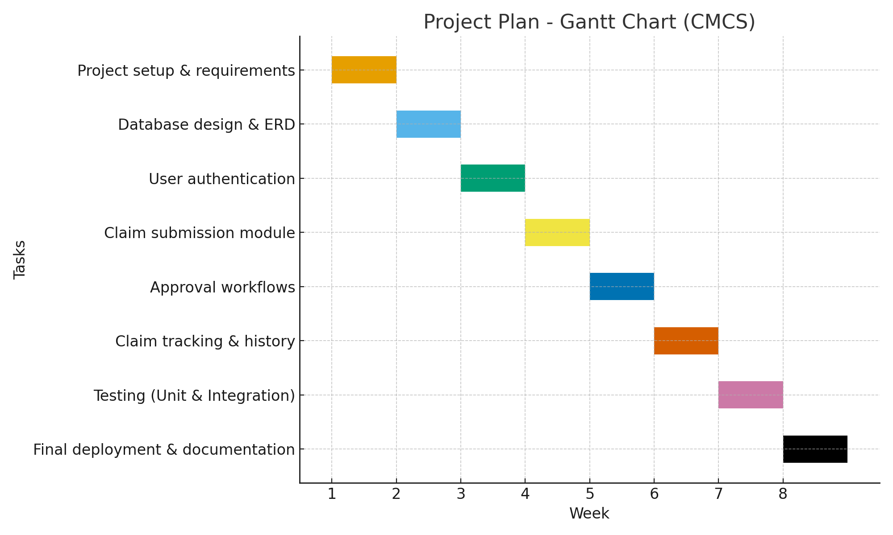

10. Risk Management
Risk | Impact | Mitigation
Lack of .NET knowledge | High | Research, tutorials, discussions
Database errors | High | Backup strategy, test queries
Delays in progress | Medium | Weekly plan, version control
Security vulnerabilities | High | Validation, role-based access control, secure file upload
Bugs in new features | High | Unit testing, peer review, incremental development

Entity diagram
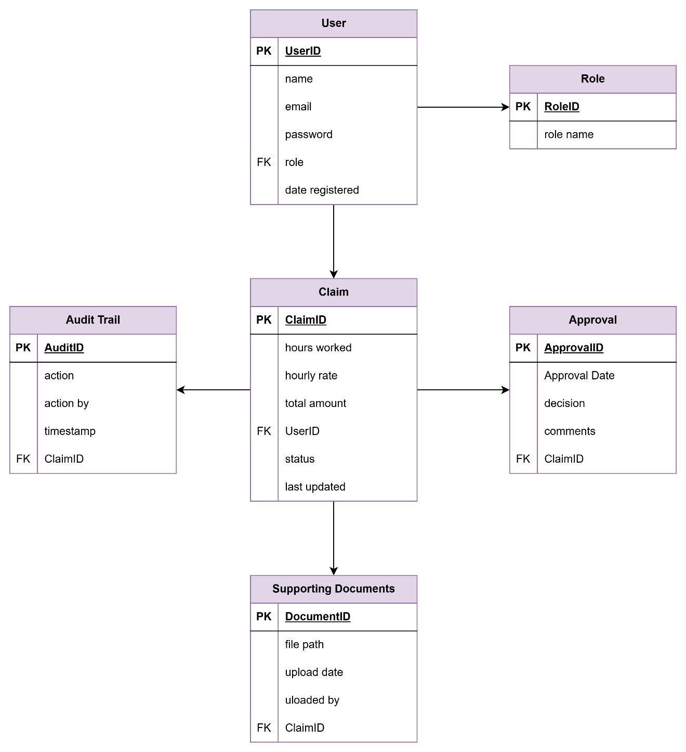

11. Success Criteria
- Fully functional CMCS with working claim submission and approval workflows.
- Secure login with role-based permissions.
- Accurate claim calculations and history tracking.
- Positive user experience (simple and intuitive GUI).
- All specified features (one-click submit, approval dashboards, file upload, tracking) are implemented and functional.
- The application is reliable, demonstrated by passing unit tests.
- Code is managed effectively using version control.

12. Enhancements & Lecturer Feedback Implementation

Instruction
- One-Click Claim Submission
- Dedicated Approval Dashboards
- Secure Document Upload
- Transparent Status Tracking
- Reliability & Unit Testing
- Version Control

Implementation Plan
A "Submit New Claim" button will be prominently placed on the lecturer dashboard. The submission form will be clean, intuitive, and use a consistent color scheme.
Separate view pages will be created for Coordinators and Managers. These dashboards will list pending claims in a table format with clear details and prominent 'Approve'/'Reject' buttons for each claim.
An `input type="file"` element will be added to the claim form. Server-side code will validate file type (pdf, docx, xlsx) and size before saving to a secure directory and linking the file path to the claim in the database. The filename will be displayed upon selection.
A "Track My Claims" page for lecturers will display each claim's status using clear text labels (e.g., 'Pending', 'Approved', 'Rejected'). Status will update in real-time as approvers act.
A separate test project will be created. Unit tests will be written for key functions: claim submission, status update, file upload validation, and user authentication. Try-catch blocks will be used for graceful error handling with user-friendly messages.
Git will be used for source control. Changes will be committed and pushed to GitHub at least 5 times during Part 2 development, with clear, descriptive commit messages (e.g., "FEAT: Implement file upload for claims").

Reference List:
1. Microsoft. (2023). ASP.NET Core Documentation. Retrieved from
<https://learn.microsoft.com/aspnet/core>
2. Microsoft. (2023). SQL Server Documentation. Retrieved from
<https://learn.microsoft.com/sql>
3. GitHub. (2023). Version Control with Git. Retrieved from
<https://docs.github.com/>
4. ISO/IEC. (2018). ISO/IEC 25010:2018 Systems and software engineering --- System and software quality models.
5. Sommerville, I. (2016). Software Engineering (10th ed.). Pearson.
6. Pressman, R. S., & Maxim, B. R. (2020). Software Engineering: A Practitioner's Approach (9th ed.). McGraw-Hill.
7. Draw io https://app.diagrams.net/?src=about#
8. xUnit Project. (2023). xUnit.net Documentation. Retrieved from <https://xunit.net/>

